**Hospital procedures for the paediatric game**

Injection procedure for older kids

1st scene: Reception

Background image:

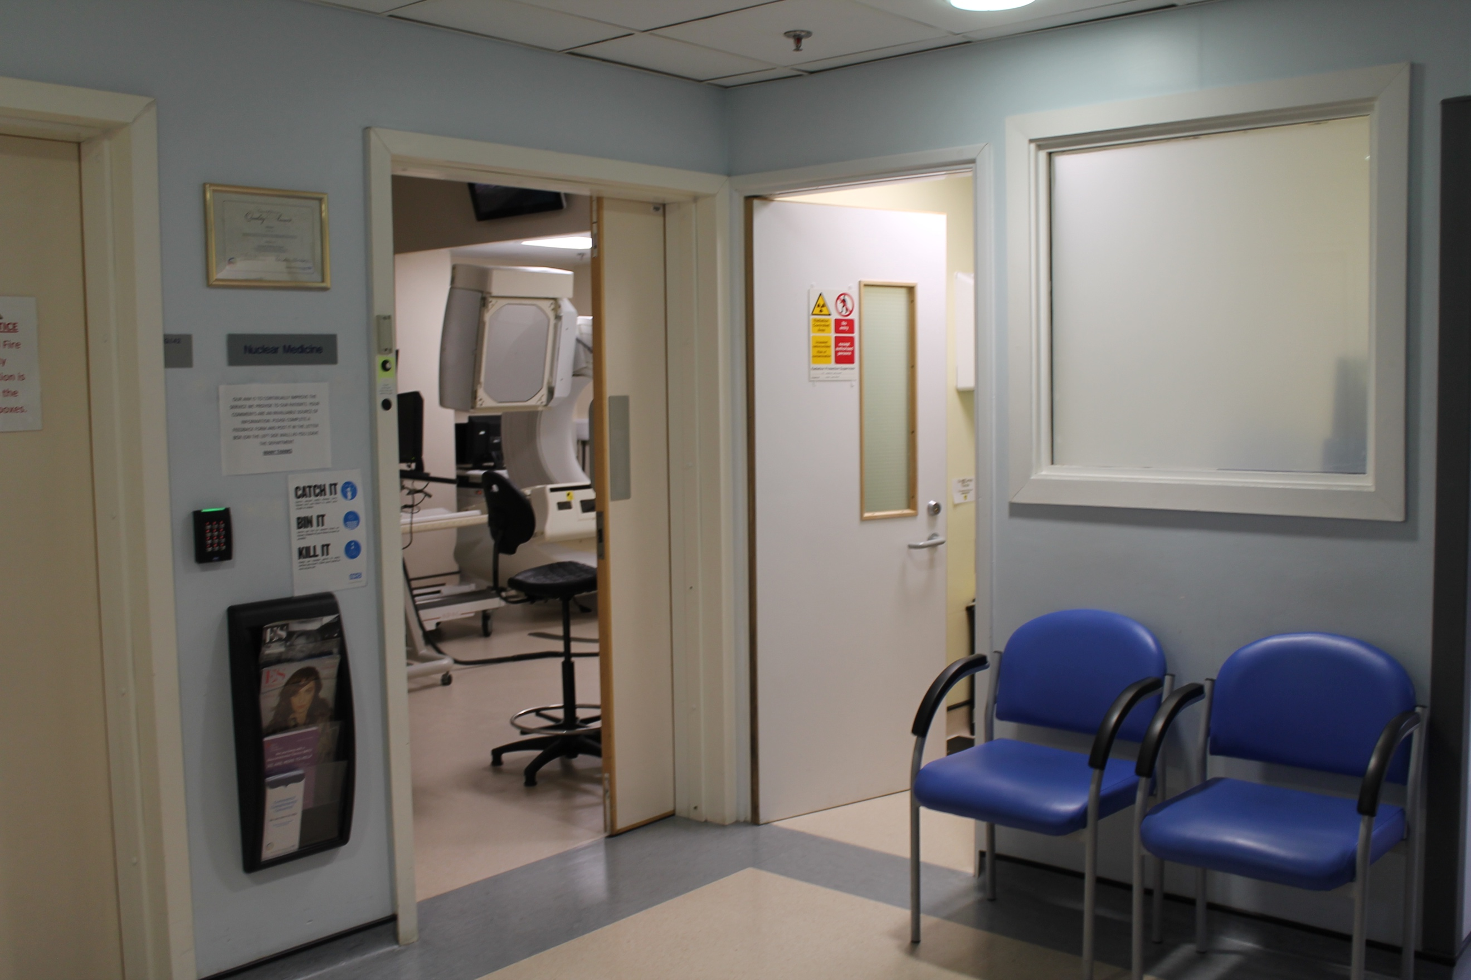

Description: Firstly, the patients arrive in the reception. The parents could be shown waiting with them and this could be a scene where the kids are introduced to the staff. Additionally, there could be a kind of leaflet in the magazine holder that the users could pick up to read instructions before the doctor or nurse called them to apply the cream. The user could click on the doctor or nurse to proceed to the next scene.

2nd scene: Applying the cream

Background image:

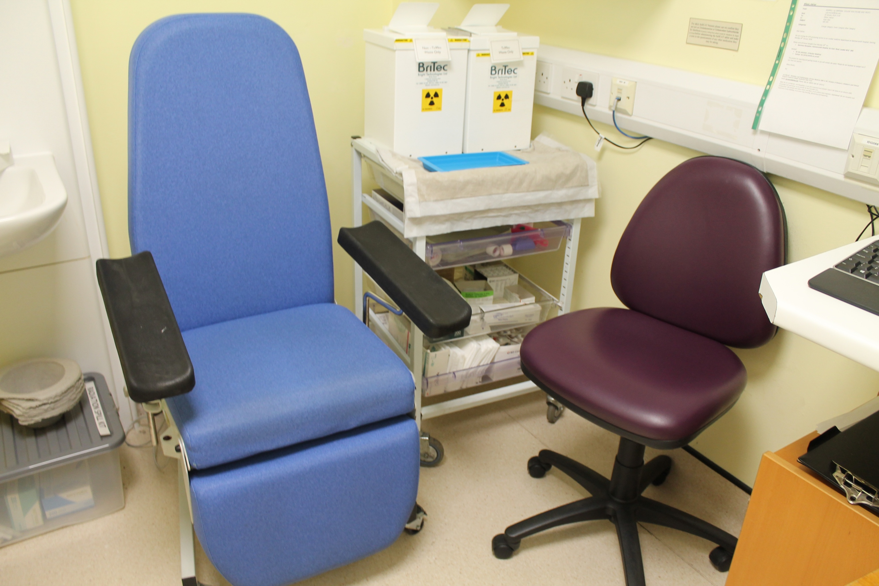

Description: The doctor or nurse could briefly describe what happens in this scene. After that the user can use drag the correct tool from a set of tools to apply the cream (the hospital calls it the "magic cream") either on the back of the hand, the elbow or the foot, which are all areas where you can see the veins clearly. To proceed, the user could click on a button.

3rd scene: Waiting for injection

Background image:

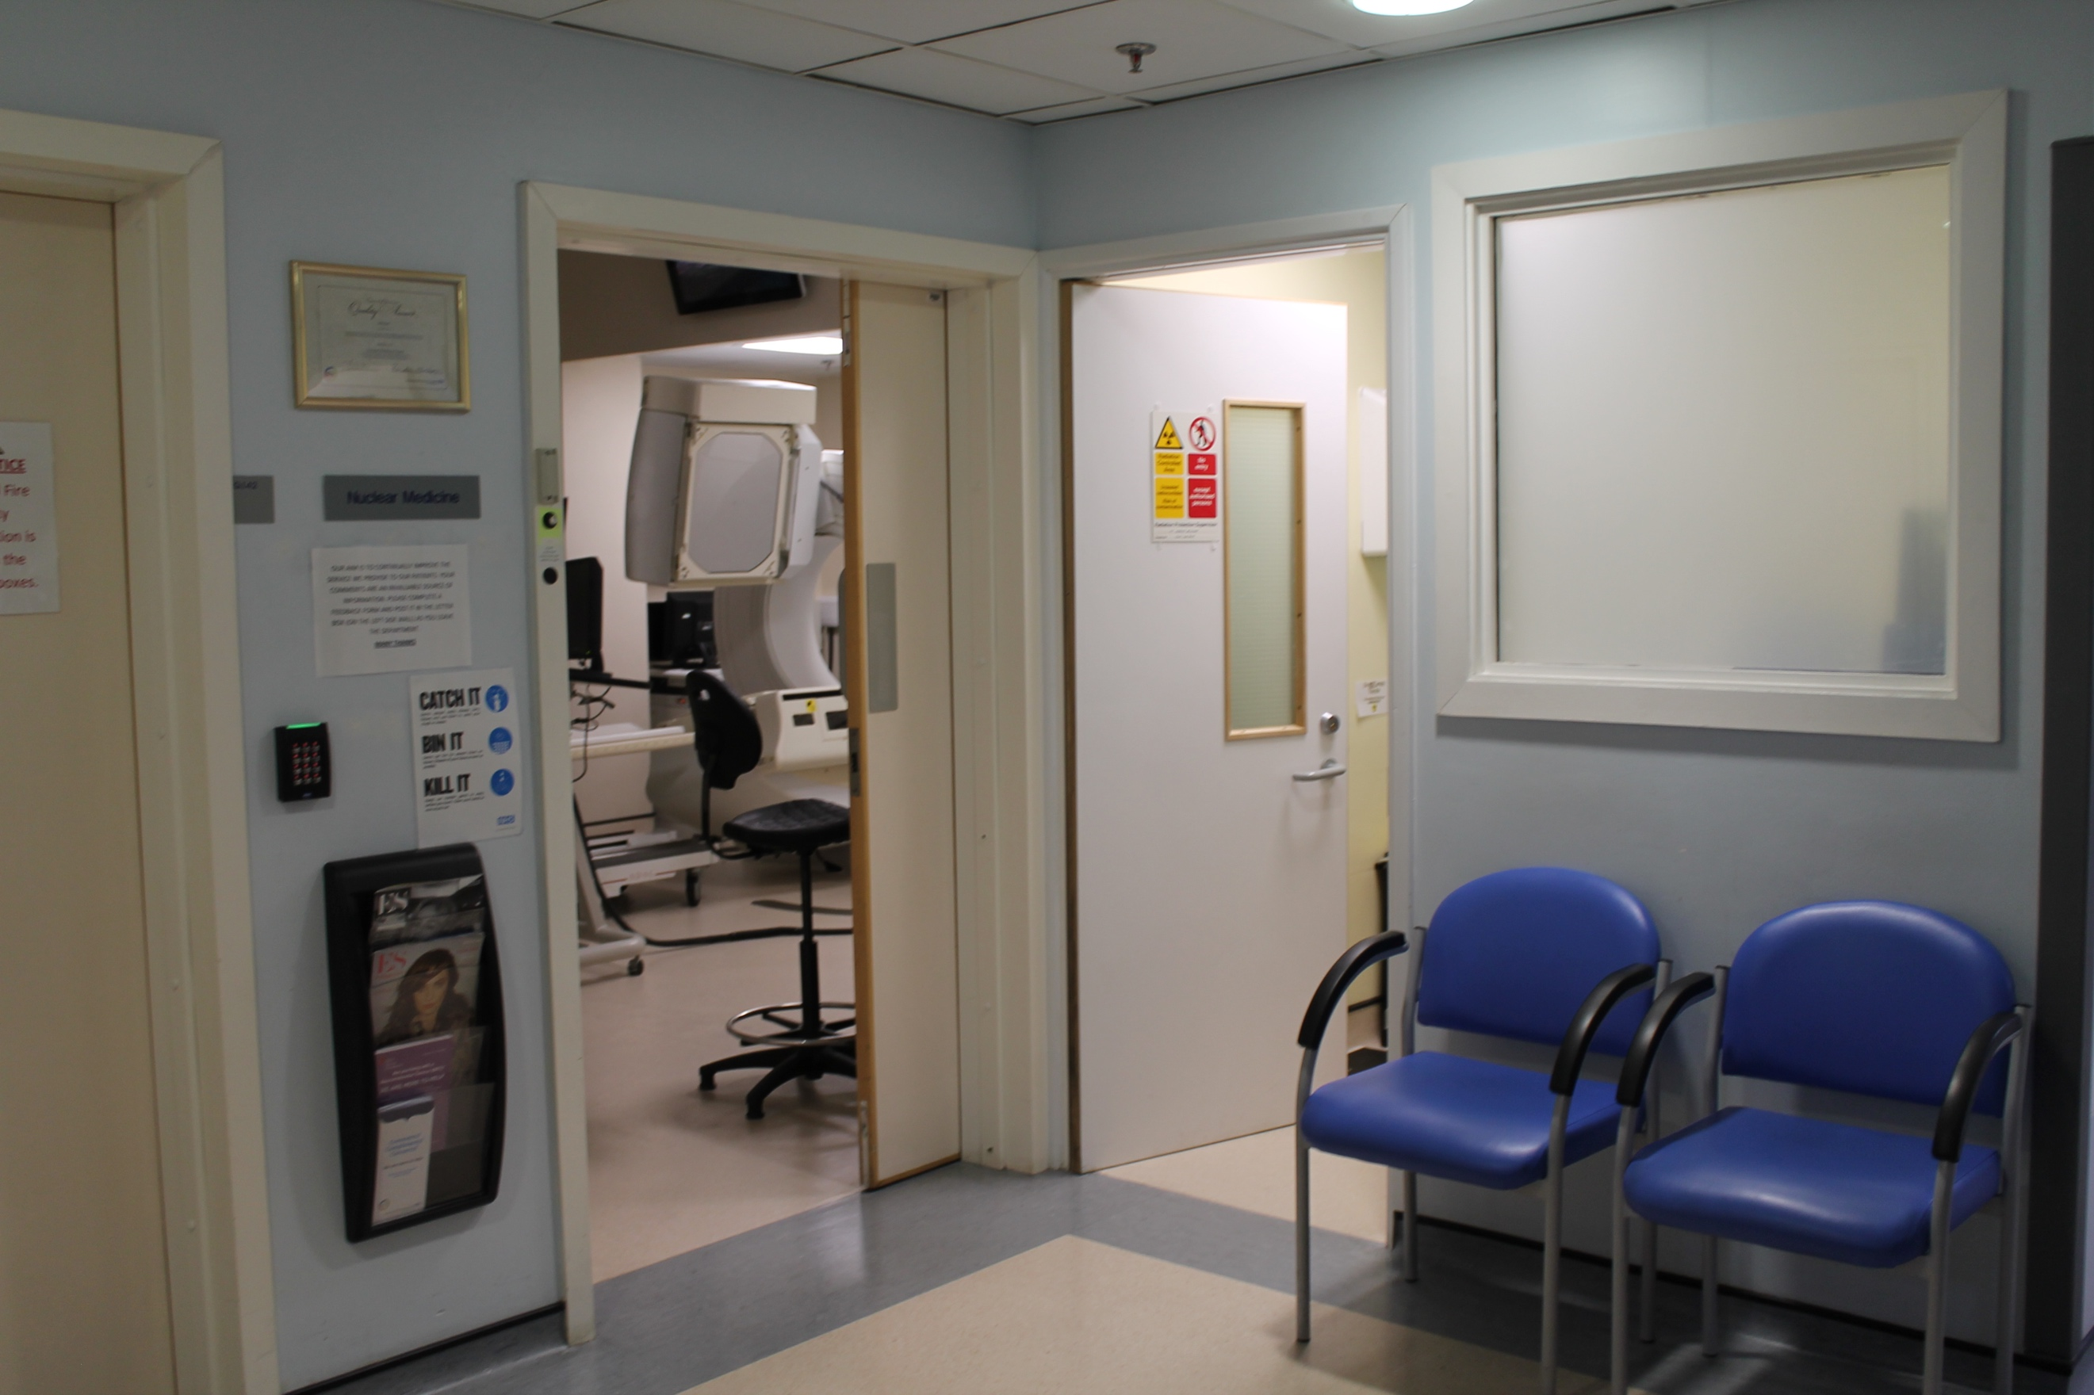 or 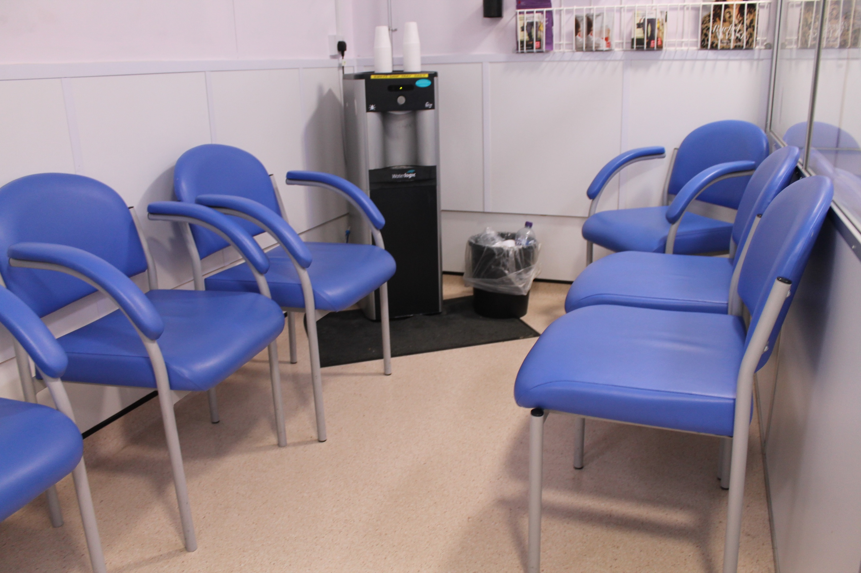

Description: The patients must wait 45 minutes until the area where the cream was applied is numb. There could be a clock or timer showing the time passing (obviously a lot faster) and also an easter egg. For example, there could be a phone where they click and a little game comes up, or a magazine they click on to see the cover. When the time has passed, the user can click on a button to proceed.

4th scene: Injection

Background image:

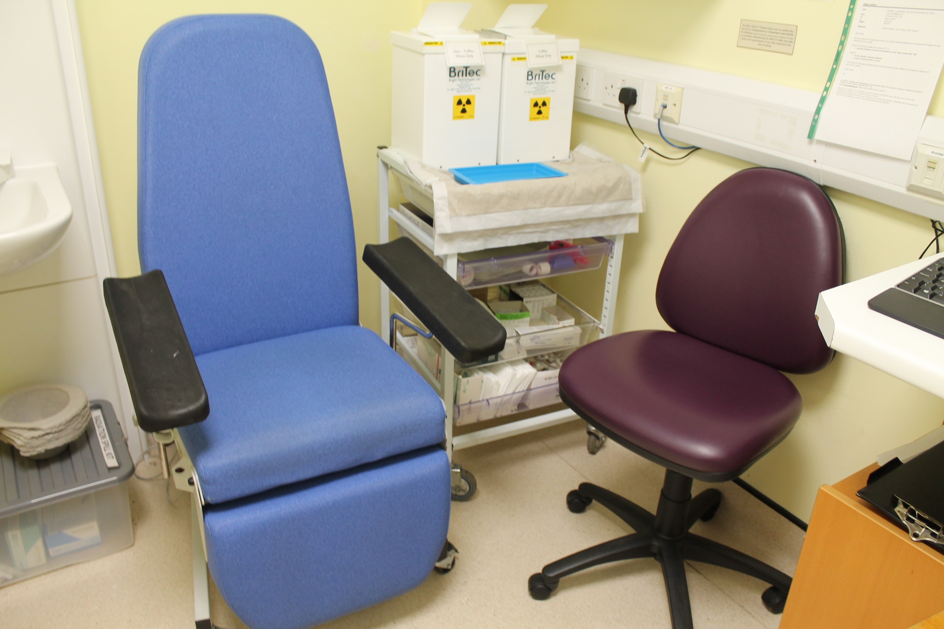

Description: The doctor or nurse could briefly describe what happens in this scene. After that the user can drag the correct tool from a set of tools to inject the radioactive material

on the area that was numbed by the cream.

5th scene: Scan

Background image:

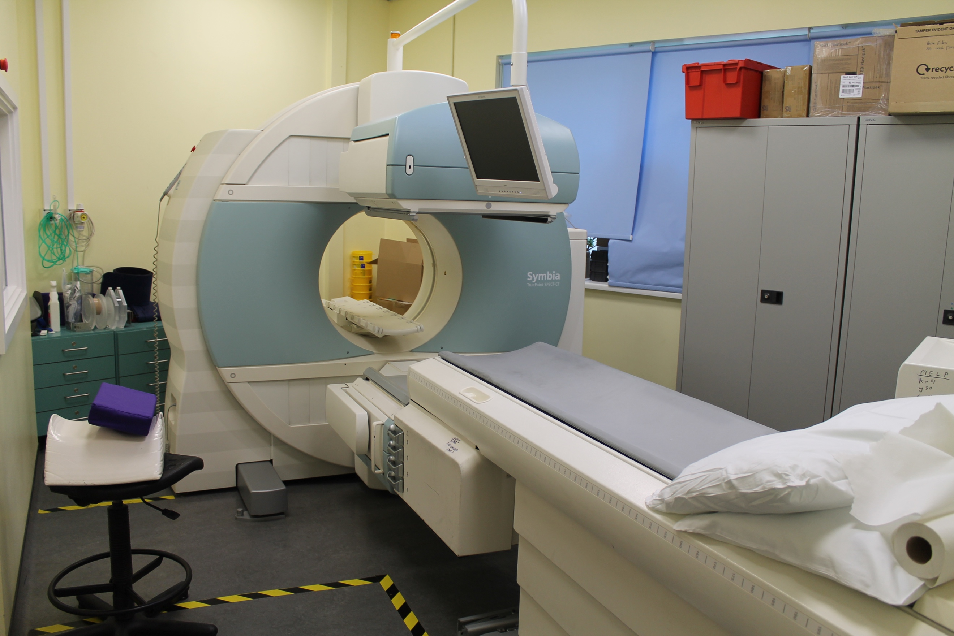

Description: The doctor or nurse could briefly describe what happens in this scene. After that the user could click on the bed to lay down on it, and then click on the camera to make it start. When the scan is finished, the user can click on a button to proceed.

6th scene: End scene

Background image:

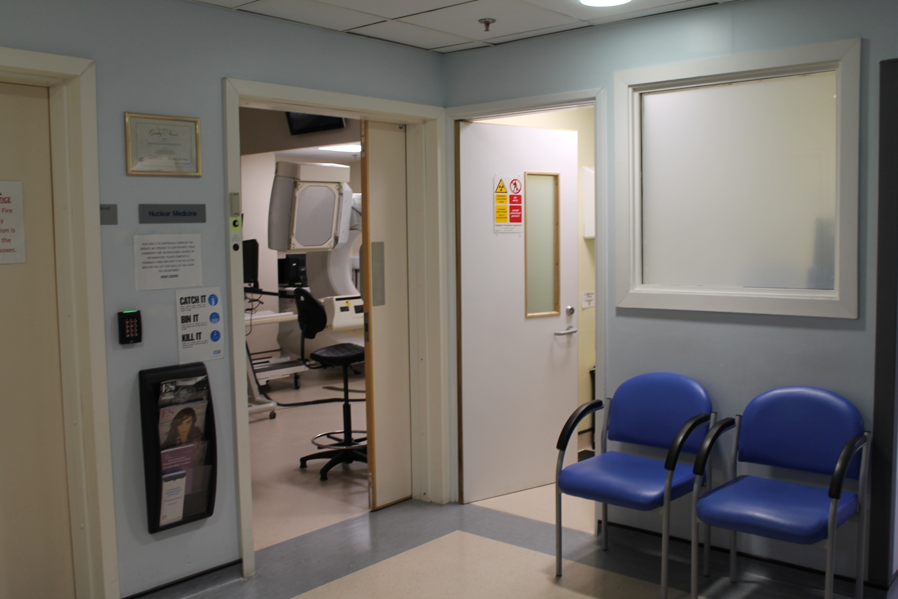

Description: A simple scene where the doctor can just say “Well done!” or something similar to it. After that the user can click on a button to go back to the age and procedure selection.

Ingestion procedure for older kids

1st scene: Reception

Background image:

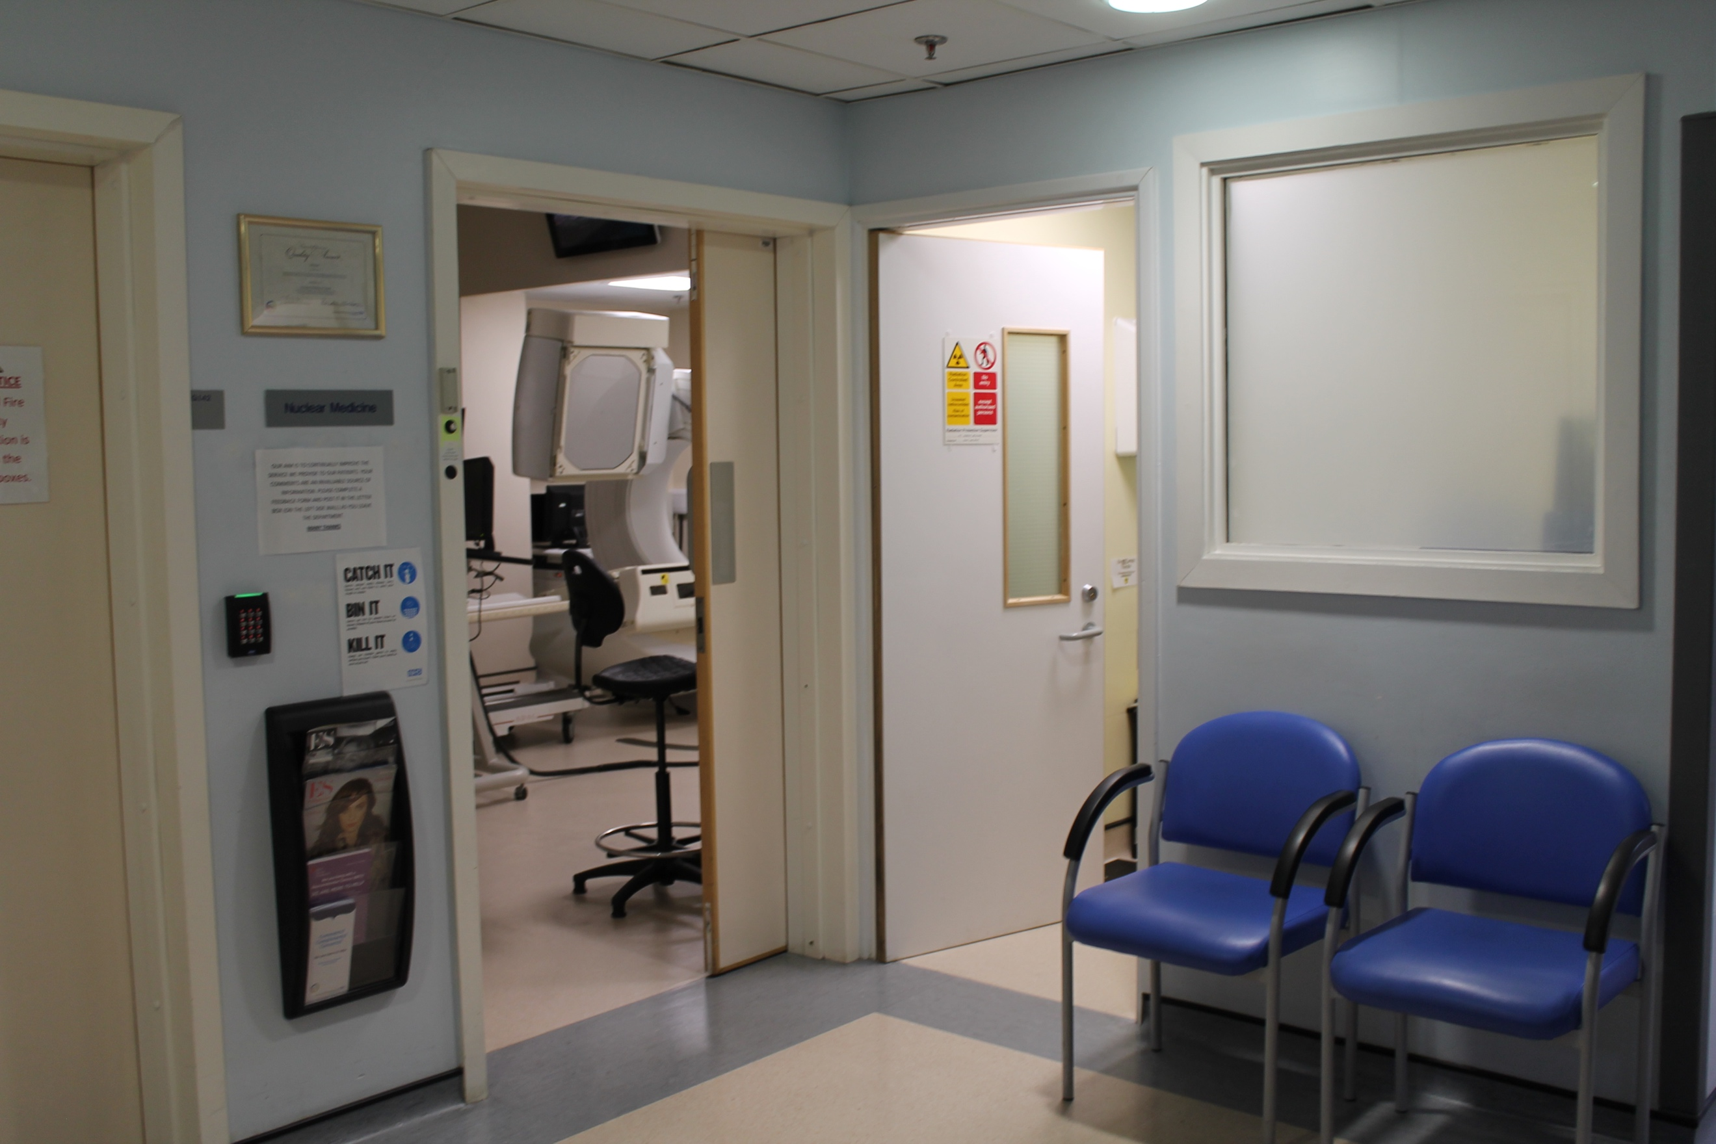

Description: Firstly, the patients arrive in the reception. There could be a kind of leaflet in the magazine holder that the users could pick up to read instructions before the doctor or nurse called them for the injection. The user could click on the doctor or nurse to proceed to the next scene.

2nd scene: Ingestion

Background image:



Description: The doctor or nurse could briefly describe what happens in this scene. After that the user could drag the plate of food from the doctor to the kid and then keep clicking on it until the food is all gone. To proceed, the user could click on a button.

3rd scene: Scan

Background image:

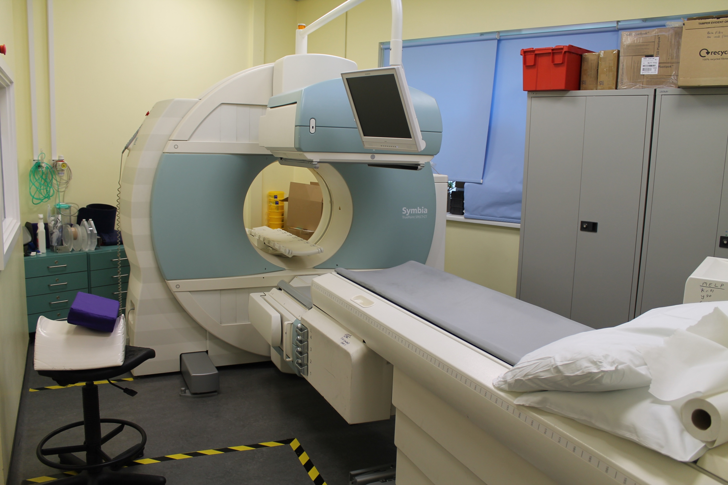

Description: The doctor or nurse could briefly describe what happens in this scene. After that the user could click on the bed to lay down on it, and then click on the camera to make it start. When the scan is finished, the user can click on a button to proceed.

4th scene: End scene

Background image:

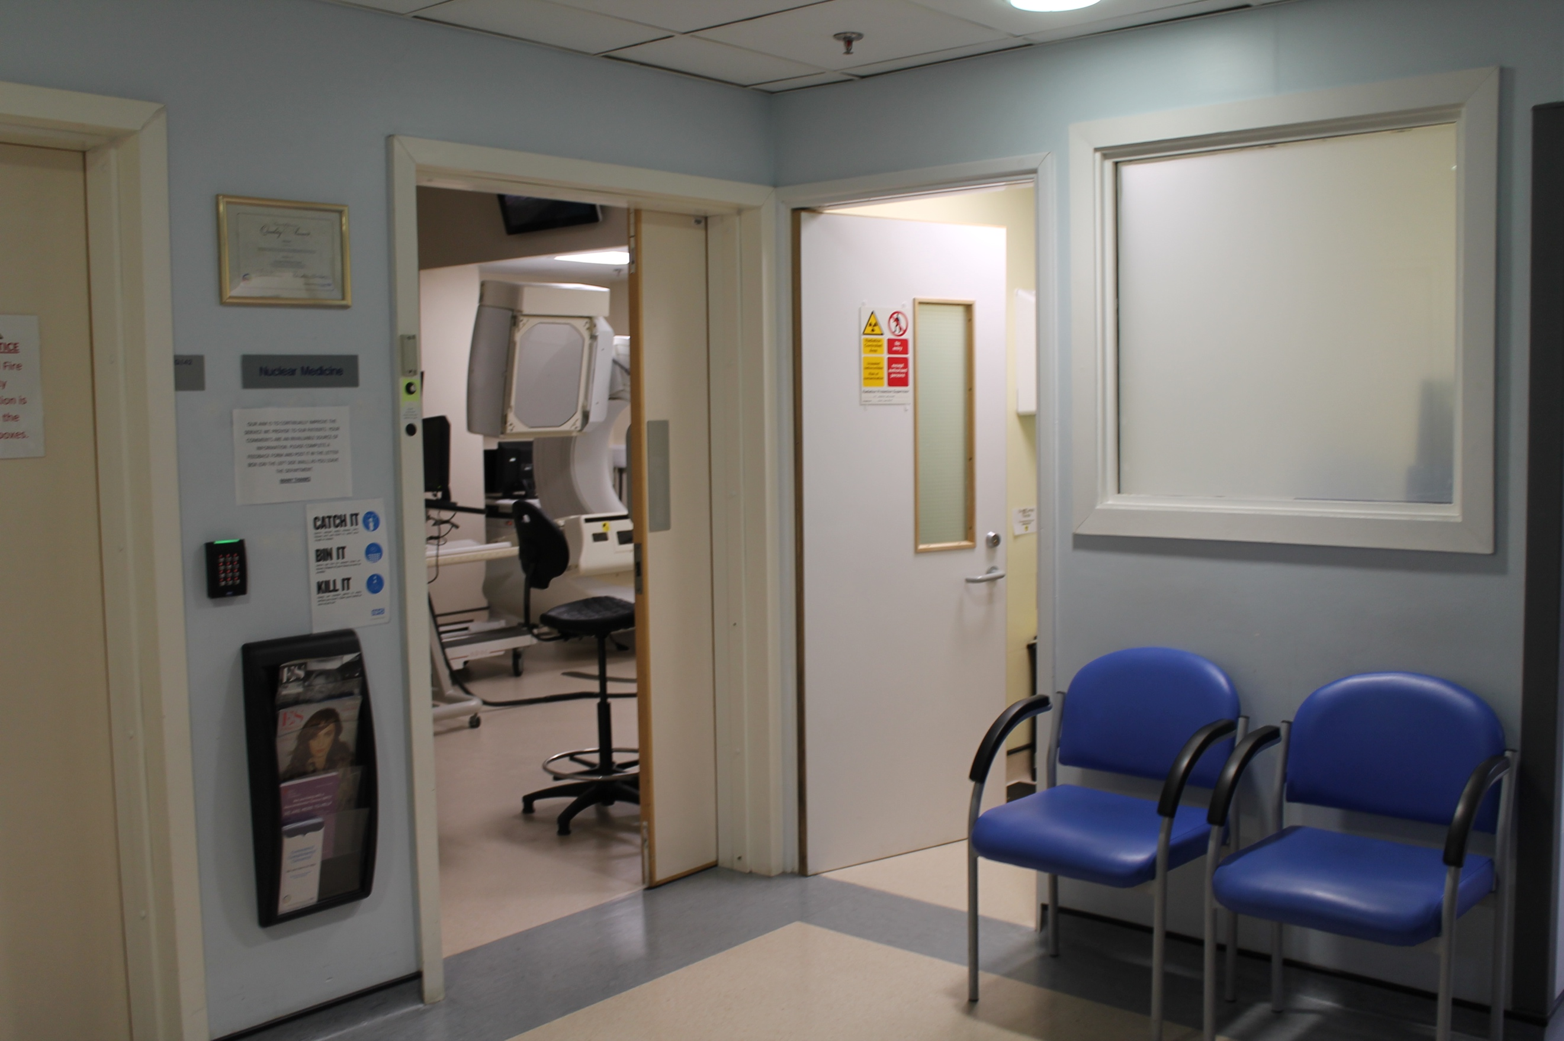

Description: A simple scene where the doctor can just say “Well done!” or something similar to it. After that the user can click on a button to go back to the age and procedure selection.

Injection procedure for younger kids

1st scene: Reception

Background image:



Description: Firstly, the patients arrive in the reception. The doctor or nurse could describe briefly the whole process before they go apply the cream. The user could click on the doctor or nurse to proceed to the next scene.

2nd scene: Applying the cream

Background image:

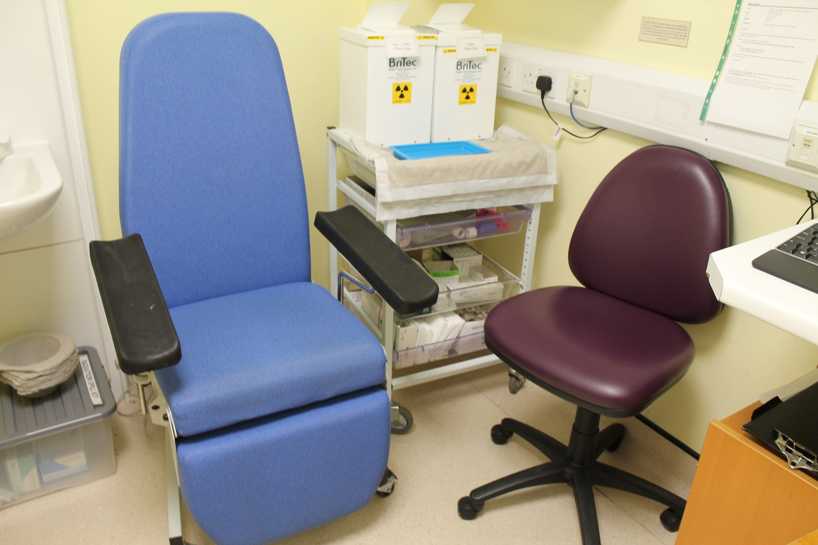

Description: The doctor or nurse could briefly describe what happens in this scene. After that the user can simply click on the cream tube to apply the cream (this is easier from the version for older kids as they don’t need to drag and drop the correct tool, they only need to click on the cream tube shown) either on the back of the hand, the elbow or the foot, which are all areas where you can see the veins clearly. To proceed, the user could click on a button.

3rd scene: Waiting for injection

Background image:

 or 

Description: The patients must wait 45 minutes until the area where the cream was applied is numb. There could be a clock or timer showing the time passing (obviously a lot faster) and also an easter egg. For example, there could be a phone where they click and a little game comes up, or a magazine they click on to see the cover. When the time has passed, the user can click on a button to proceed.

4th scene: Injection

Background image:

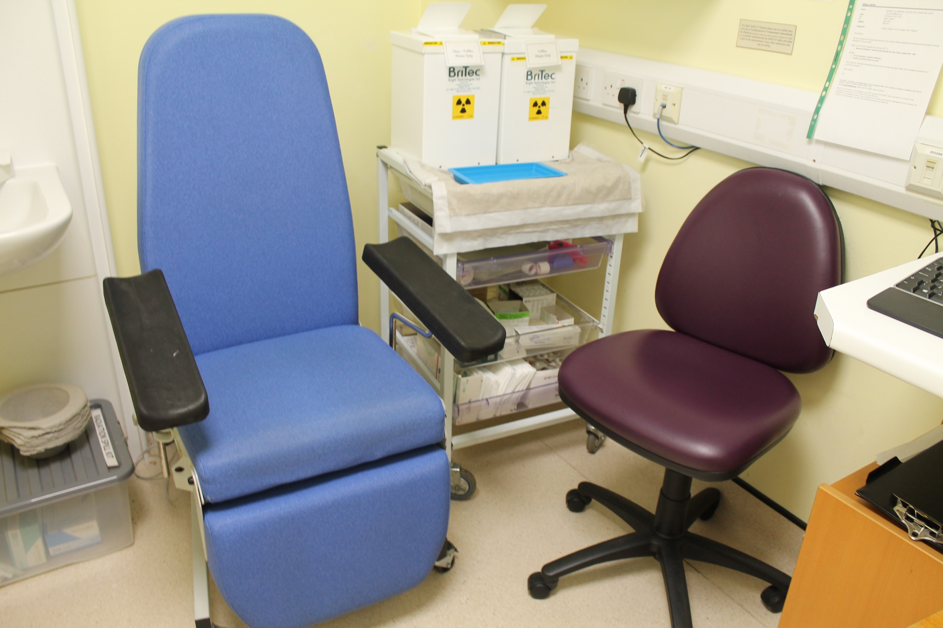

Description: The doctor or nurse could briefly describe what happens in this scene. After that the user can click on the syringe (so it’s also made easier from the version for older kids) to inject the radioactive material on the area that was numbed by the cream.

5th scene: Scan

Background image:

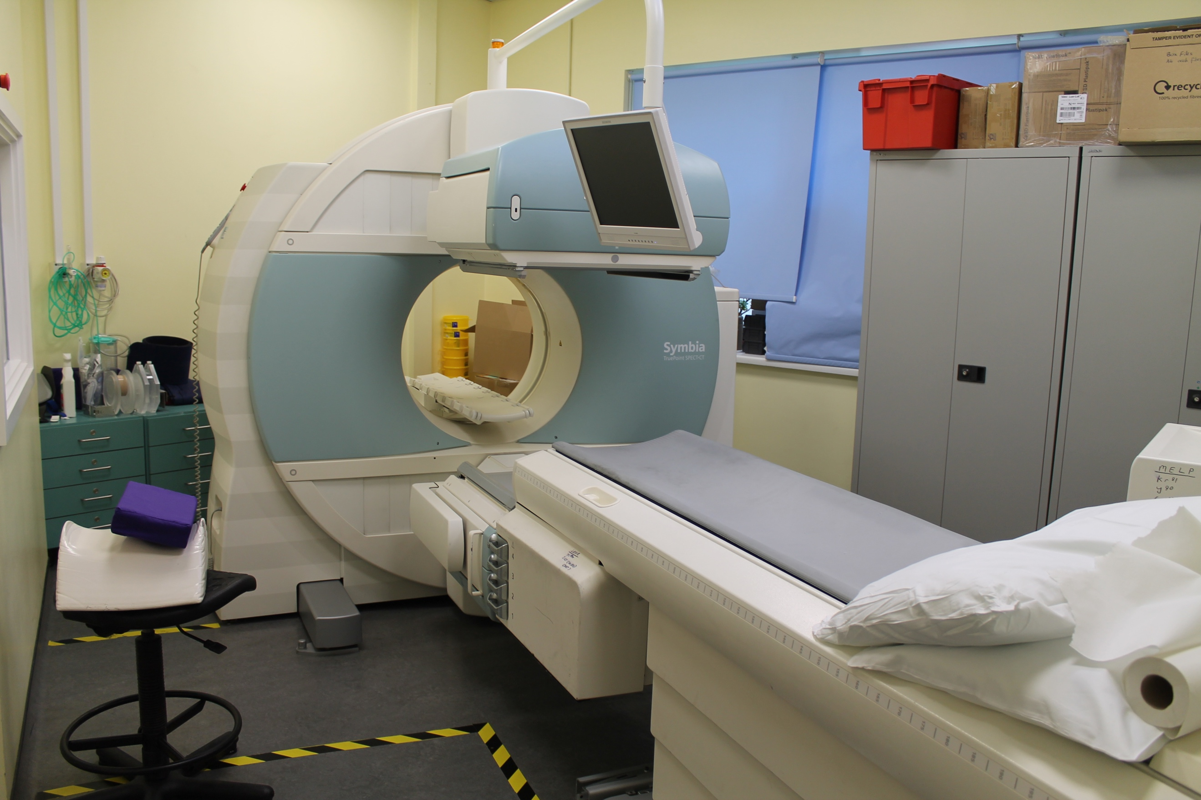

Description: The doctor or nurse could briefly describe what happens in this scene. After that the user could click on the bed to lay down on it, and then the camera would start automatically. When the scan is finished, the user can click on a button to proceed.

6th scene: End scene

Background image:

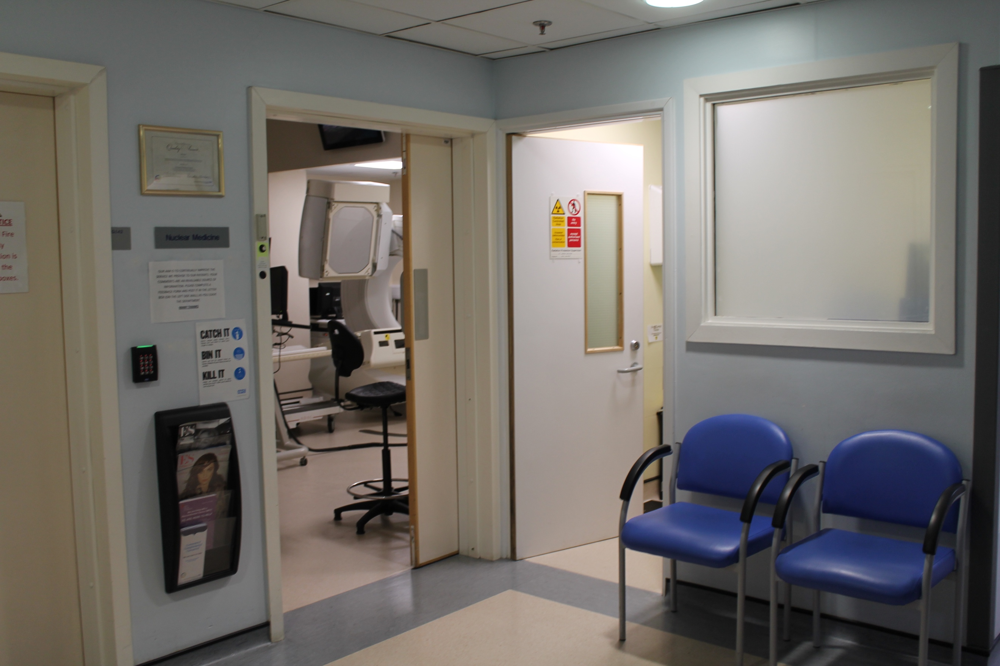

Description: A simple scene where the doctor can just say “Well done!” or something similar to it. After that the user can click on a button to go back to the age and procedure selection.

Ingestion procedure for younger kids

1st scene: Reception

Background image:



Description: Firstly, the patients arrive in the reception. The doctor or nurse could describe briefly the whole process before they go apply the cream. The user could click on the doctor or nurse to proceed to the next scene.

2nd scene: Ingestion

Background image:



Description: The doctor or nurse could briefly describe what happens in this scene. After that the user could click on the bottle of milk (which contains the radioactive material) that the doctor is holding. This is made easier as they don’t need to drag a plate and keep clicking on it until empty. After that, the user could click on a button to proceed.

3rd scene: Scan

Background image:



Description: The doctor or nurse could briefly describe what happens in this scene. After that the user could click on the bed to lay down on it, and then the camera would start automatically. When the scan is finished, the user can click on a button to proceed.

4th scene: End scene

Background image:



Description: A simple scene where the doctor can just say “Well done!” or something similar to it. After that the user can click on a button to go back to the age and procedure selection.